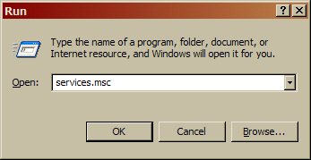
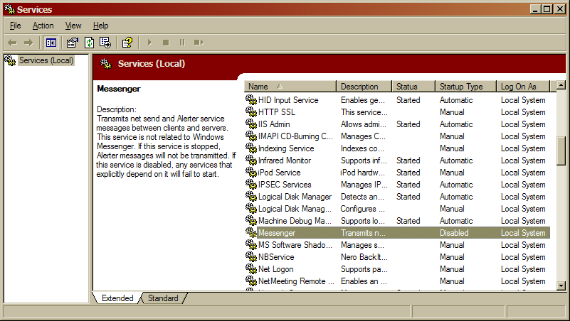

Summary
My Messenger service is already turned off. XP SP2 does it by default now, and before that, I did it myself. That service is annoying. No, not the possible spam. I never got that. I always got the immature people at LAN parties running “MESSENGER BOMB.BAT”. And that is more annoying than any spam I could ever get through Messenger service.

